TEAM N0:

|  |  |
| --- | --- |
| NAME | ROLL NO |
| M. Ashwini | 21881A05G8 |
| M. Ananya | 21881A05H0 |
| K. KrishnaVarshitha | 21881A05F8 |

# Over View about Project:

Our project is about “STUDENT REGISTRATION”. Student Registration forms are used for any student to register in the course of their particular institution,and their particular details are also entered,so that we can get the complete information of the student . The information is registered and then we can access their data .

# Screenshots of project:

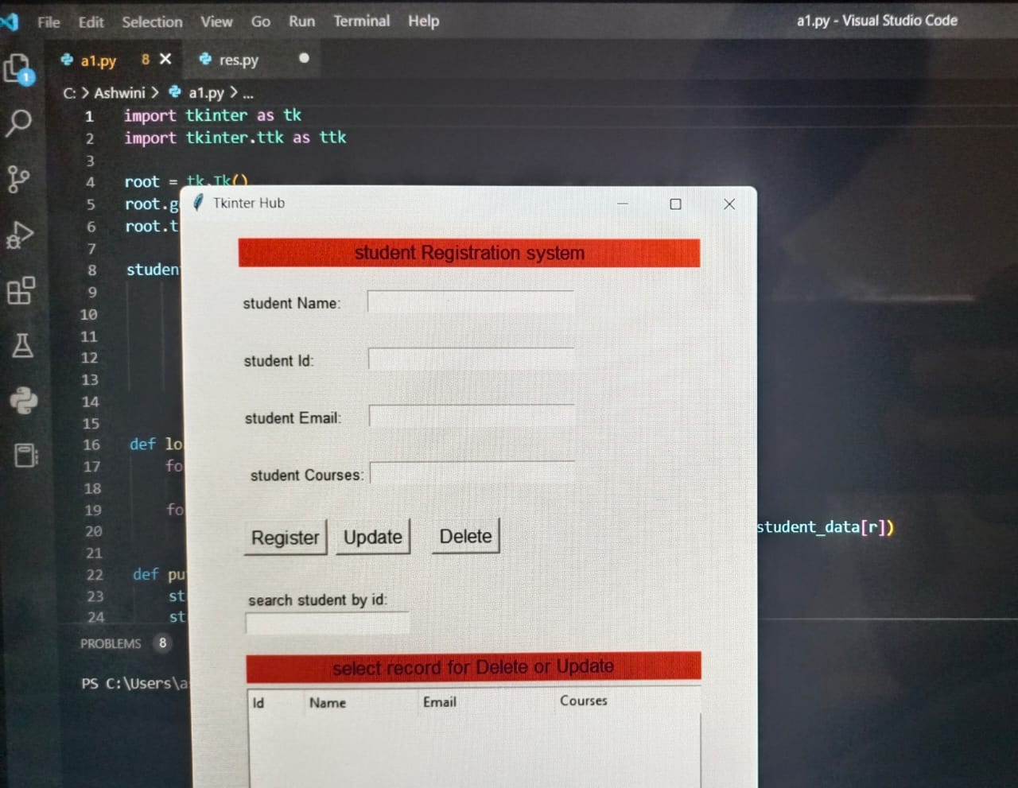

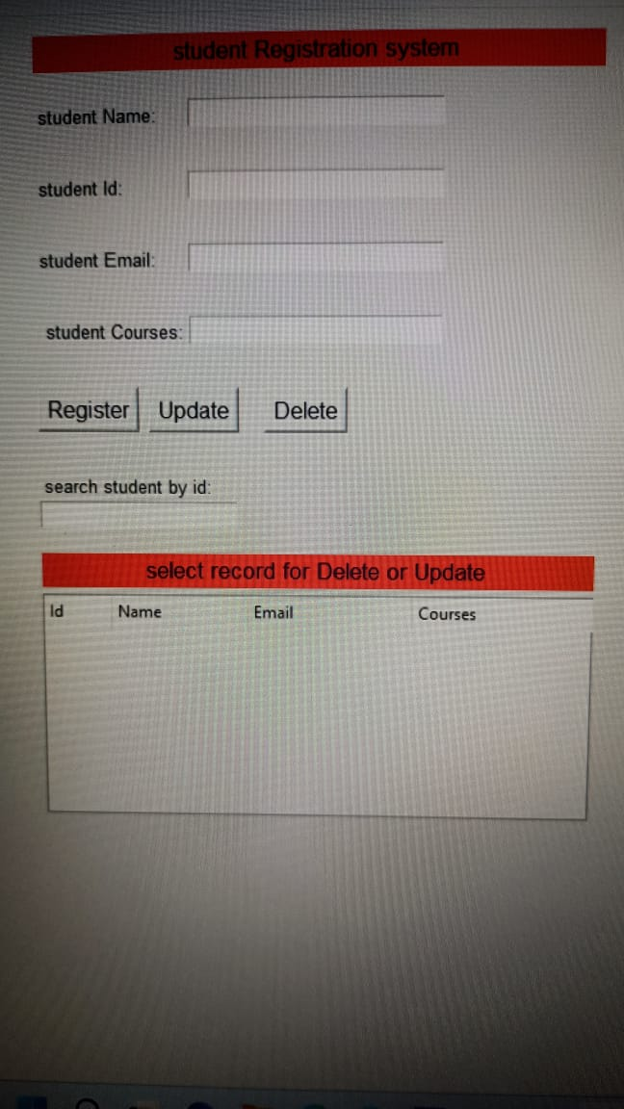

DATABASE STRUCTURE

|  |  |  |  |
| --- | --- | --- | --- |
| ID | NAME | EMAIL | COURSES |
| 1 | Jon | [jonstudent@gmail.cc](mailto:jonstudent@gmail.cc) | Python,c,c++ |
| 2 | Smith | smithstudent@gmail.c | Python,c,c++ |
| 3 | Luck | [luckstudent@gmail.c](mailto:luckstudent@gmail.c) | Python,java,c++ |
| 4 | Jack | [jackstudent@gmail.c](mailto:jackstudent@gmail.c) | Python,c,c++ |
| 5 | Jell | [jellstudent@gmail.c](mailto:jellstudent@gmail.c) | Python,c,shell |
| 6 | Mari | [maristudent@gmail.c](mailto:maristudent@gmail.c) | Python,c |

# Code:

import tkinter as tk

import tkinter.ttk as ttk

root = tk.Tk()

root.geometry('500x600')

root.title('Tkinter Hub')

student_data=[]

def load_student_data():

for item in record_table.get_children():

record_table.delete(item)

for r in range(len(student_data)):

record_table.insert(parent='',index='end',text='',iid=r,values=student_data[r])

def add_student_data(stud_id,stud_name,stud_email,stud_courses):

student_data.append([stud_id,stud_name,stud_email,stud_courses])

head_frame = tk.Frame(root)

heading_lb = tk.Label(head_frame,text='student Registration system',

font=('Bold',13),

bg='red')

heading_lb.pack(fill=tk.X,pady=5)

student_id_lb = tk.Label(head_frame,text='student Id:', font=('Bold',10))

student_id_lb.place(x=0, y=100)

student_id = tk.Entry(head_frame, font=('Bold',10))

student_id.place(x=110, y=50, width=180)

student_name_lb = tk.Label(head_frame,text='student Name:', font=('Bold',10))

student_name_lb.place(x=0, y=50)

student_name = tk.Entry(head_frame, font=('Bold',10))

student_name.place(x=110, y=100, width=180)

student_email_lb = tk.Label(head_frame,text='student Email:', font=('Bold',10))

student_email_lb.place(x=0, y=150)

student_email = tk.Entry(head_frame, font=('Bold',10))

student_email.place(x=110, y=150, width=180)

student_courses_lb = tk.Label(head_frame,text=' student Courses:', font=('Bold',10))

student_courses_lb.place(x=0, y=200)

student_courses = tk.Entry(head_frame, font=('Bold',10))

student_courses.place(x=110, y=200, width=180)

register_btn = tk.Button(head_frame,text='Register', font=('bold',12),command=lambda: add_student_data(student_id.get(),student_name.get(),student_email.get(),student_courses.get()))

register_btn.place(x=0,y=250)

update_btn = tk.Button(head_frame,text='Update', font=('bold',12))

update_btn.place(x=80,y=250)

delete_btn = tk.Button(head_frame,text='Delete',font=('bold',12))

delete_btn.place(x=163,y=250)

clear_btn = tk.Button(head_frame,text='Delete',font=('bold',12))

clear_btn.place(x=163,y=250)

head_frame.pack(pady=10)

head_frame.pack_propagate(False)

head_frame.configure(width=400,height=300)

search_bar_frame=tk.Frame(root)

search_lb=tk.Label(search_bar_frame,text='search student by id:',font=('Bold',10))

search_lb.pack(anchor=tk.W)

search_entry=tk.Entry(search_bar_frame,font=('Bold',10))

search_entry.pack(anchor=tk.W)

search_bar_frame.pack(pady=0)

search_bar_frame.pack_propagate(False)

search_bar_frame.configure(width=400,height=50)

record_frame=tk.Frame(root)

record_lb=tk.Label(record_frame,text='select record for Delete or Update',bg='red',font=('Bold',13))

record_lb.pack(fill=tk.X)

record_table=ttk.Treeview(record_frame)

record_table.pack(fill=tk.X, pady=5)

record_table['column']=['Id','Name','Email','Courses']

record_table.column('#0',anchor=tk.W,width=0,stretch=tk.NO)

record_table.column('Id',anchor=tk.W,width=50)

record_table.column('Name',anchor=tk.W,width=100)

record_table.column('Email',anchor=tk.W,width=120)

record_table.column('Courses',anchor=tk.W,width=160)

record_table.heading('Id',text='Id',anchor=tk.W)

record_table.heading('Name',text='Name',anchor=tk.W)

record_table.heading('Email',text='Email',anchor=tk.W)

record_table.heading('Courses',text='Courses',anchor=tk.W)

record_frame.pack(pady=10)

record_frame.pack_propagate(False)

record_frame.configure(width=400,height=200)

root.mainloop()

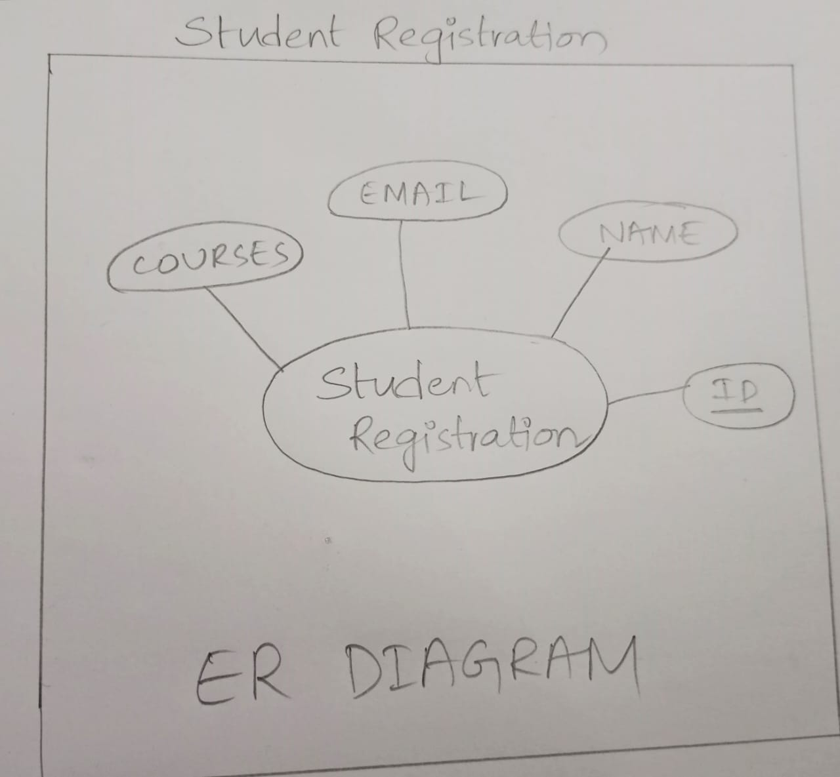

# JUSTIFICATION ABOUT WHICH NORMAL FORM IS SATISFIED BY THE TAKEN TABLES FOR PROJECT:

